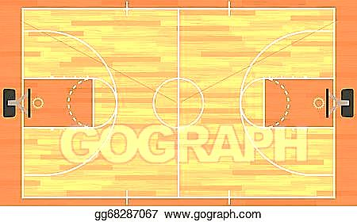
Created by Mario Gonzalez but credit to Joson Steele @PerkettPE

Each day you get to choose your workout! Pick one of the daily exercises and look at the American Heart Association Link of the Day. Also, pick an exercise to do from the daily choices list if you want. Remember to drink water daily. Wash your hands often for 20 seconds. Eat fruits and vegetables with every meal. HAVE FUN, BE SAFE, and BE ACTIVE. PLEASE, post pictures on Class Dojo exercising.
Monday  April 13 | Tuesday  April 14 | Wednesday  April 15 | Thursday  April 16 | Friday  April 17
Pre-3 – 2nd  GONoodle  Workout  (Click on Link)  OR  Play a tag game  for 10 minutes | Pre-3 – 2nd  Warm up 5 min  Sharp PE Website  OR  Dance to your  favorite music for  10 minutes | Pre-3 – 2nd  Captain America Workout  (Click on Link)  OR  Sharp PE Website | Pre-3 – 2nd  Warm up 5 min  Sharp PE Website  OR  Run in place or  run laps for 5  minutes | Pre-3 – 2nd  Youtube Cardio Workout  (Click on Link)  OR  GoNoodle Workout  (Click on Link)
3rd - 5th  GONoodle  Workout  (Click on Link)  OR  Play a tag game  for 10 minutes | 3rd – 5th  Warm up 5 min  Sharp PE Website  OR  Dance to your  favorite music for  10 minutes | 3rd – 5th  Captain America Workout  (Click on Link)  OR  Sharp PE Website | 3rd – 5th  Warm up 5 min  Sharp PE Website  OR  Run in place or  run laps for 5  minutes | 3rd – 5th  Youtube Cardio Workout  (Click on Link)  OR  GoNoodle Workout  (Click on Link)
Daily Choices
Build a Fort
Plank for as long as you can
Jump rope for 10 minutes non-stop
Create your own dance and share with family
Run in place for 10 minutes
Play a Just Dance Video and dance
Play throw and Catch with a sock (form a ball with sock)
Play hide and seek

American Heart Association
Link of the Day!

Monday: Think F.A.S.T.
Tuesday: Heart Healthy Meals
Wednesday: Games Day
Thursday: Playing with Gratitude
Friday: 25 Ways to Move

