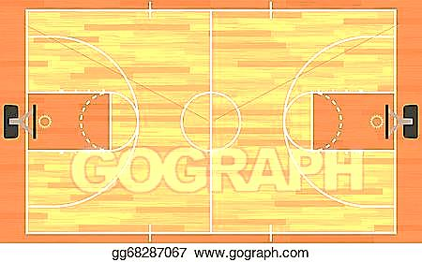
Created by Mario Gonzalez but credit to Joson Steele @PerkettPE

Each day you get to choose your workout! Pick one of the daily exercises and look at the American Heart Association Link of the Day. Also, pick an exercise to do from the daily choices list if you want. Remember to drink water daily. Wash your hands often for 20 seconds. Eat fruits and vegetables with every meal. HAVE FUN, BE SAFE, and BE ACTIVE. PLEASE, post pictures on Class Dojo exercising.
Monday  April 6 | Tuesday  April 7 | Wednesday  April 8 | Thursday  April 10 | Friday  April 11
Pre-3 – 2nd  Warm up 5 min  25 Ways to Get Moving  (Choose 5)  OR  Stand and read for 20 minutes | Pre-3 – 2nd  BATMAN Workout www.tinyurl.com/ BatWorkout  OR  BATGIRL Workout www.tinyurl.com/ BatgirlWorkout | Pre-3 – 2nd  Warm up 5 min  25 Ways to Get Moving  (Choose 5)  OR  Sharp PE Website | Pre-3 – 2nd  Get Active at Home Workout (Click on Link)  OR  Do jumping jacks for 5 minutes | Pre-3 – 2nd  Warm up 5 min  25 Ways to Get Moving  (Choose 5)  OR  GoNoodle Workout  (Click on Link)
3rd - 5th  Warm up 5 min  25 Ways to Get Moving  (Choose 5)  OR  Stand and read for 20 minutes | 3rd – 5th  BATMAN Workout www.tinyurl.com/ BatWorkout  OR  BATGIRL Workout www.tinyurl.com/ BatgirlWorkout | 3rd – 5th  Warm up 5 min  25 Ways to Get Moving  (Choose 5)  OR  Sharp PE Website | 3rd – 5th  Get Active at Home Workout (Click on Link)  OR  Do jumping jacks for 5 minutes | 3rd – 5th  Warm up 5 min  25 Ways to Get Moving  (Choose 5)  OR  GoNoodle Workout  (Click on Link)
Daily Choices
Build a Fort
Plank for as long as you can
Jump rope for 10 minutes non-stop
Create your own dance and share with family
Run in place for 10 minutes
Play a Just Dance Video and dance
Play throw and Catch with a sock (form a ball with sock)
Play hide and seek

American Heart Association
Link of the Day!

Monday: Dance it out!
Tuesday: Know you Heart
Wednesday: FINNS Missions
Thursday: Jump Around
Friday: Connect the Dots

